Children’s Rights
Short description: A six-part puzzle completed by participants by winning the missing pieces through 6 different game activities.
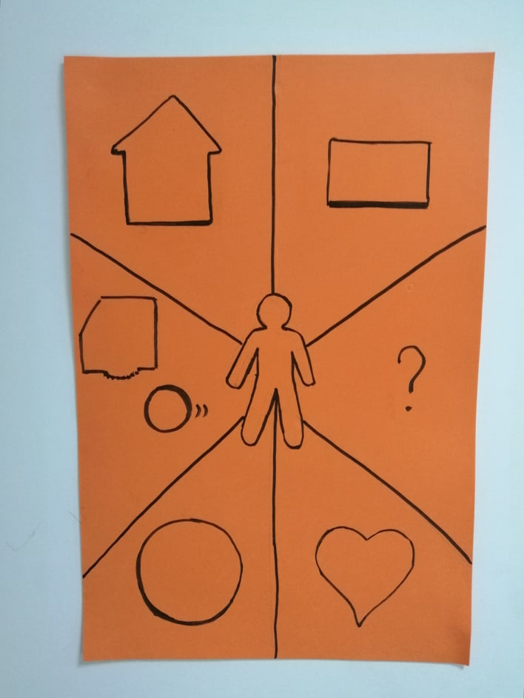
Aim: The aim of this project is to inform and sensitize young people on the topic of Children’s Rights through a variety of fun game activities which will create team spirit, empathy and raise the interest for them to discover more on the issue.
Target group: 14-18 year old
Duration: 40-60 minutes
Names: Eman Aladaileh (Jordan), Iulia Manda (Romania), Sofia Konstantinea (Greece), Yanislava Georgieva (Bulgaria), Ziad Bannour (Tunisia), Damjan Gorgioski (North Macedonia), Guillermo Torroglosa (Spain), Georgi Nonchev (Bulgaria), Sebastian Miron (Romania)
Procedure:
1) Introduction:
Aim: To explain the goal of this program.
Materials: A poster, envelopes with the pieces of the puzzle
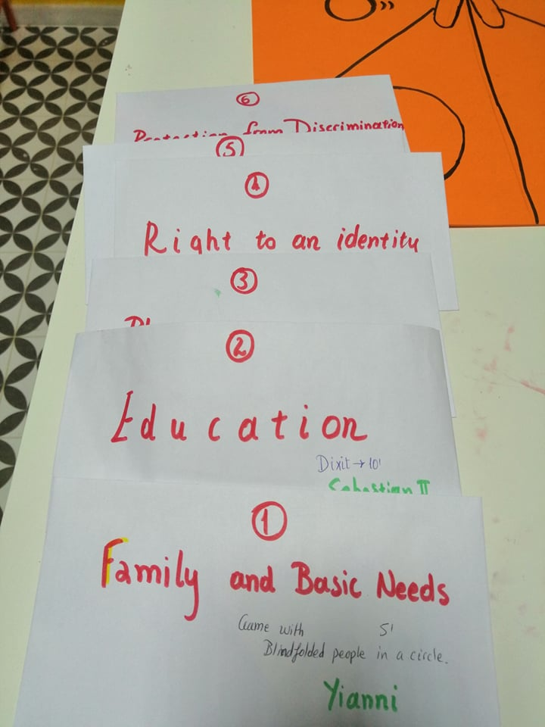
Time: 5 minutes
Procedure: The participants are presented with the poster and are asked to fill in the puzzle pieces by accomplishing different tasks on the topic of Children’s Rights. A good idea is to ask the youth if they know what ages are included in the term “Children” so that they do not feel offended or do not identify themselves with the term “children”. Note that the participants are supposed to already know each other and the facilitator(s) and have established a relationship of trust.
2) Activity 1: The Right to Family and Basic Needs (food, water, medicine, etc.)
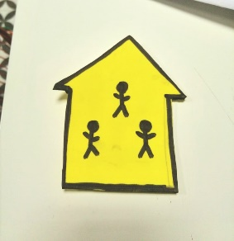
Aim: To explain the Right to Family and Basic Needs (food, water, medicine, etc.)
Materials: Enough blindfolds for all participants and ten different objects (apple, bread, bottle of water, pillow, medicine, banana, shoe, T shirt, toy, a hand of the facilitator to hold the hand of each participant as the last “object”, etc)
Time: 10’ minutes
Procedure: Young people sit close to each other in circle and close their eyes (or blindfolded if there are enough blindfolds for all) and the facilitator passes the objects around for the participants. They in turn pass the objects to each other and feel the objects. At the end they remove the blindfolds or open eyes and discuss what the basic needs are based on what they touched.
The participants are given the piece of the puzzle to put on the poster

3) Activity 2: The Right to Education
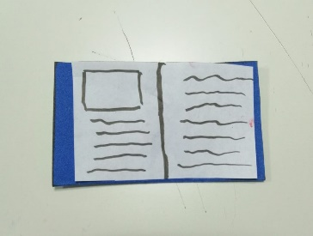
Aim: To explain the Right to Education and feel how important it is
Materials: 3-4 DIXIT cards multiplied by the number of participants
Time: 10’ minutes
Procedure: Participants are asked to look at the cards and choose the card they think mostly represents how they feel about education or school. (Note: some may pick cards with positive feelings but some may also pick negative ones). Then, the show the card and explain why the picked it. If the numbers of participants is bigger than ten people, then they can be divided in groups of 4-6 people.
The participants are given the piece of the puzzle to put on the poster
4) Activity 3: The Right to Play and Recreation
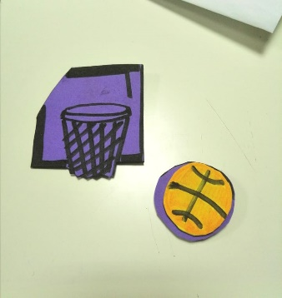
Aim: To be informed of the right to play, have fun and learn to support others when they make mistakes, rather than make fun of them
Materials: A ball
Time: 5 minutes
Procedure: The participants move to a wide space (outside if it’s possible) and are instructed to pass the ball to the person next to them until the circle is complete. Every time a person takes the ball, they have to say a word of something they love/like. When the circle is complete the first time, the facilitator instructs the participants to throw the ball to someone in the circle without it falling down. They still have to be ready to say a word of a thing they like. If they cannot think immediately or stumble upon a word, then everyone shouts “Whoo-hoo!” and move a step to the right.
At the end of the activity explain to the participants the importance of play and fun and the importance of not making fun of someone for making a mistake but encouraging him/her to move on (“Whoo-hoo!”).
The participants are given the piece of the puzzle to put on the poster

5) Activity 4: The Right to Identity
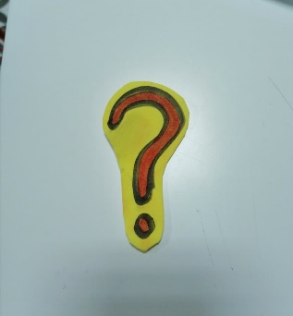
Aim: To help participants realize the right to identity
Materials: A4 pieces of paper and pens, one of each for every participant
Time: 10’ minutes
Procedure: Participants are asked to draw their palm on a piece of paper and then write on each finger one thing that makes up their identity (name, nationality, etc). Make sure you give an example of the identity elements as it may be a bit confusing. It is ok if they write unexpected things, such as “blond”. At the end of the activity they share what they wrote and the meaning of right to identity is briefly explained.
The participants are given the piece of the puzzle to put on the poster

6) Activity 5: The Right to Privacy
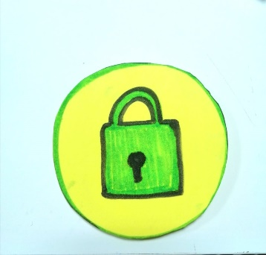
Aim: To explain the Right to Privacy and throw light on shades of it that are important for teenagers.
Materials: Computer, projector and mobile phones, one for every team of 4-6 people
Time: 10’ minutes
Procedure: The participants play the game. Short briefing can be asked if they knew of these rights and explain why a diary is private from parents’ surveillance (unless it’s a matter of security for the child) but the information on their mobile is not private from their parents (as one has to be of age to be in social media or have a mobile phone account).
The participants are given the piece of the puzzle to put on the poster

7) Activity 6: Protection from Discrimination
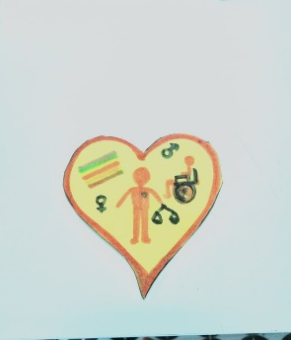
Aim: To sensitize the participants in the topic of discrimination/to evaluate the whole program
Materials: 3-4 DIXIT cards multiplied by the number of participants
Time: 5-6’ minutes
Procedure: Participants are asked to sit in a circle. Then, they change places every time one of the following statements applies to them. After the second question, a chair is removed and one of the participants has to remain standing every time.
Questions: Change places if…
- …you like ice cream
-…you are a girl
- …you like football
-…you play football
-…you have long hair
-…you wear glasses
-…you have ever been made fun of
-…you have ever made fun of somebody
-…you feel bad about making fun of somebody
-…you are Muslim
-…you have travelled abroad
-…you have ever felt you don’t belong to your country
-…anyone has ever told you that you don’t belong to your country
-…you love chocolate
-…you had fun today
-…you feel you have learnt something about children’s rights today
-…you would like to help inform others about children’s rights.

The puzzle is now COMPLETE!
